Student’s Name: Kibet Brian
Admission Number: 190814
Lecturer’s Name: Mr. Talo Harrison
Course Unit: MST 8303 Penetration Testing, PT
Course Code: MST 8303
Lab - Scanning for Vulnerabilities Using Nessus Docker
Date: July 8th, 2025
Lab - Scanning for Vulnerabilities Using Nessus
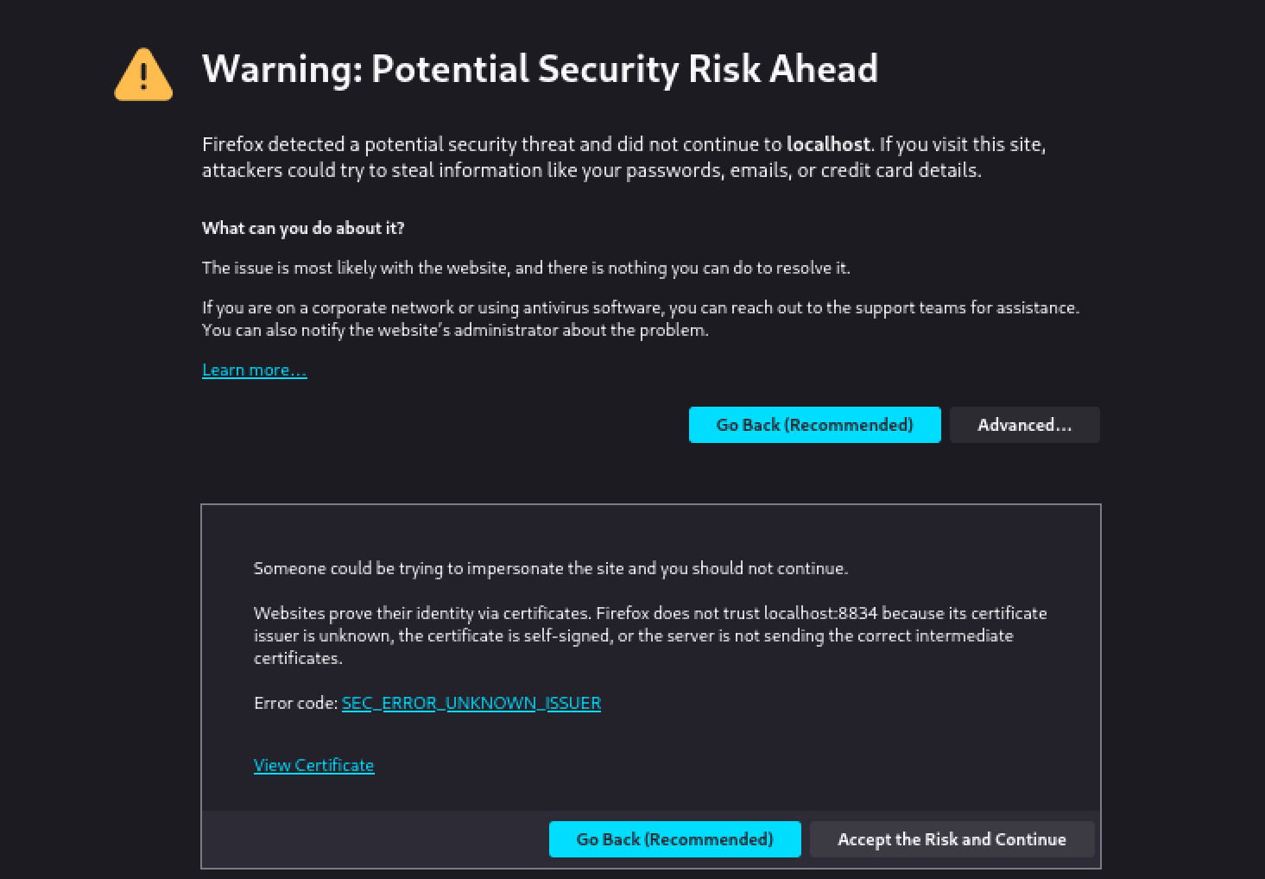

NESSUS running in web interface.
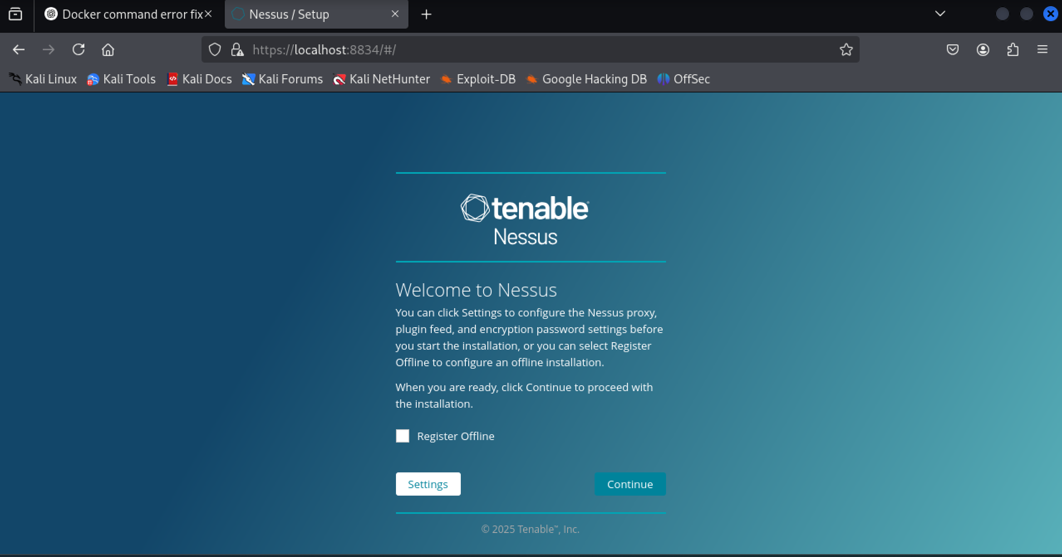

Plug-in initialization.
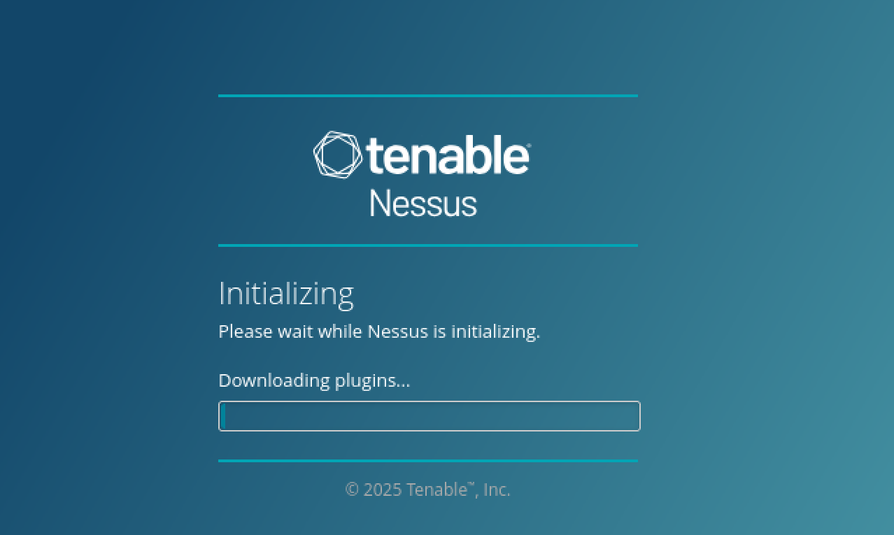

The download failed on first attempt. – This was due to limited disk space, after resizing, the results are as shown below.
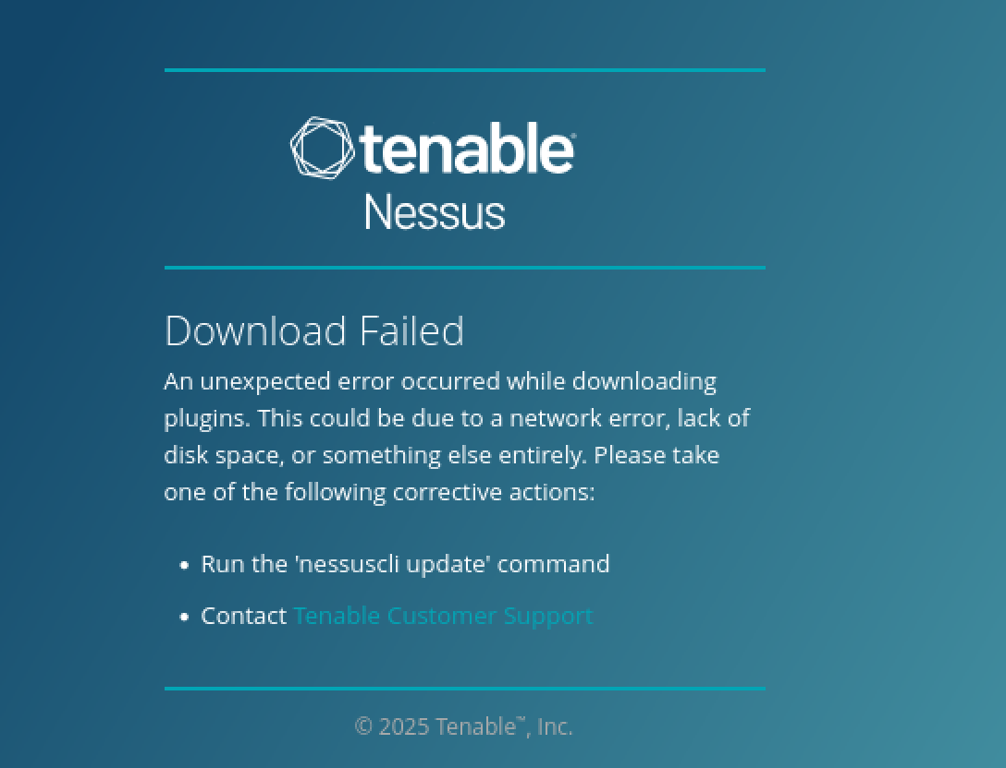
Logging in.
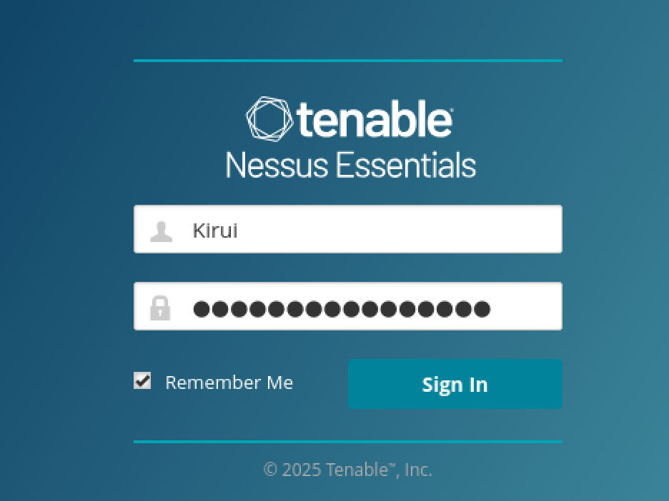

Compiling plugins.
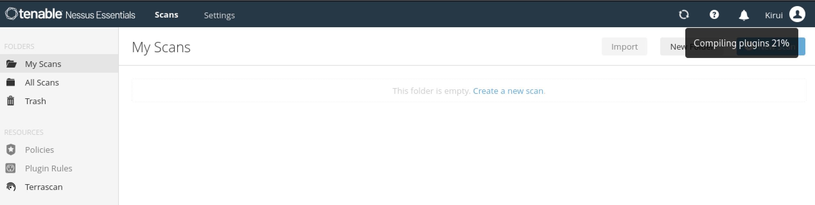

My Kali IP address.
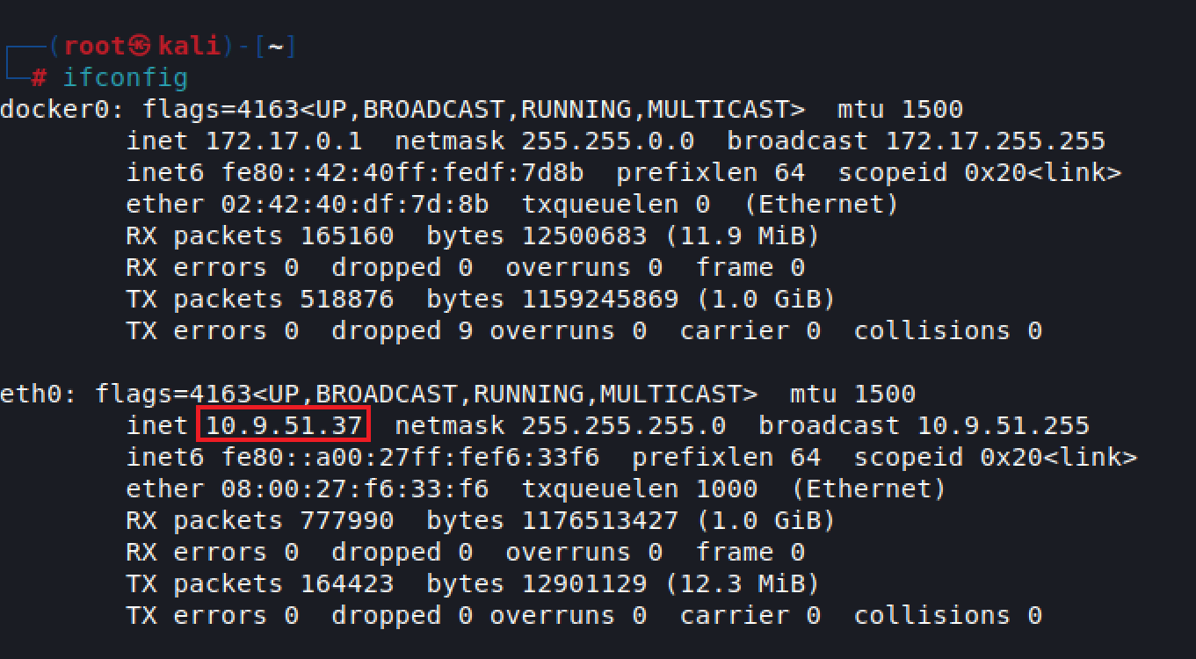
Setting up scan target(s) on Advanced Scan.
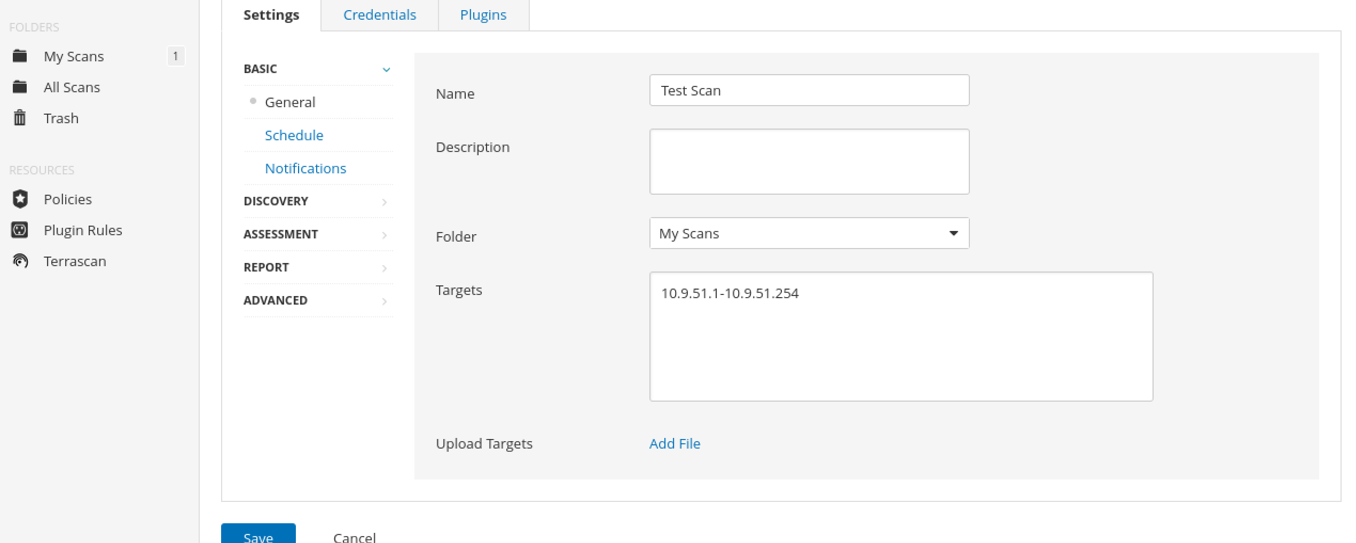

Ongoing scan.
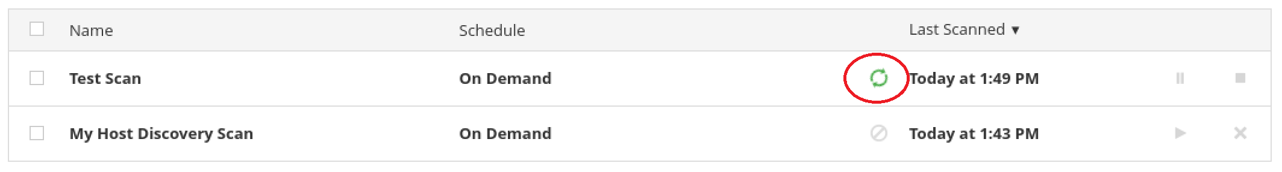

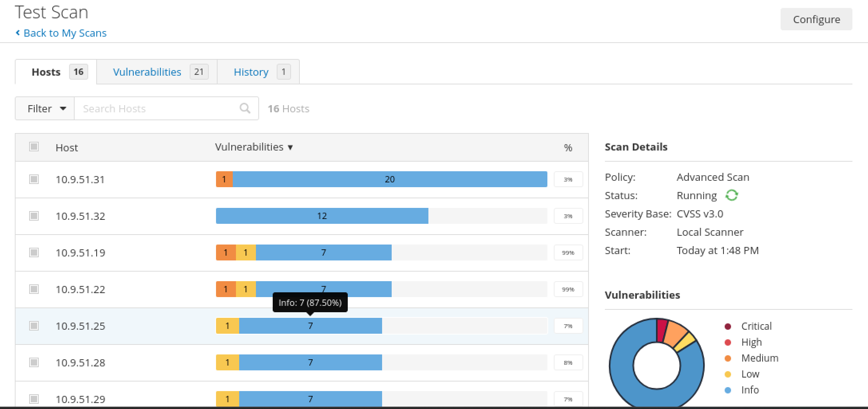
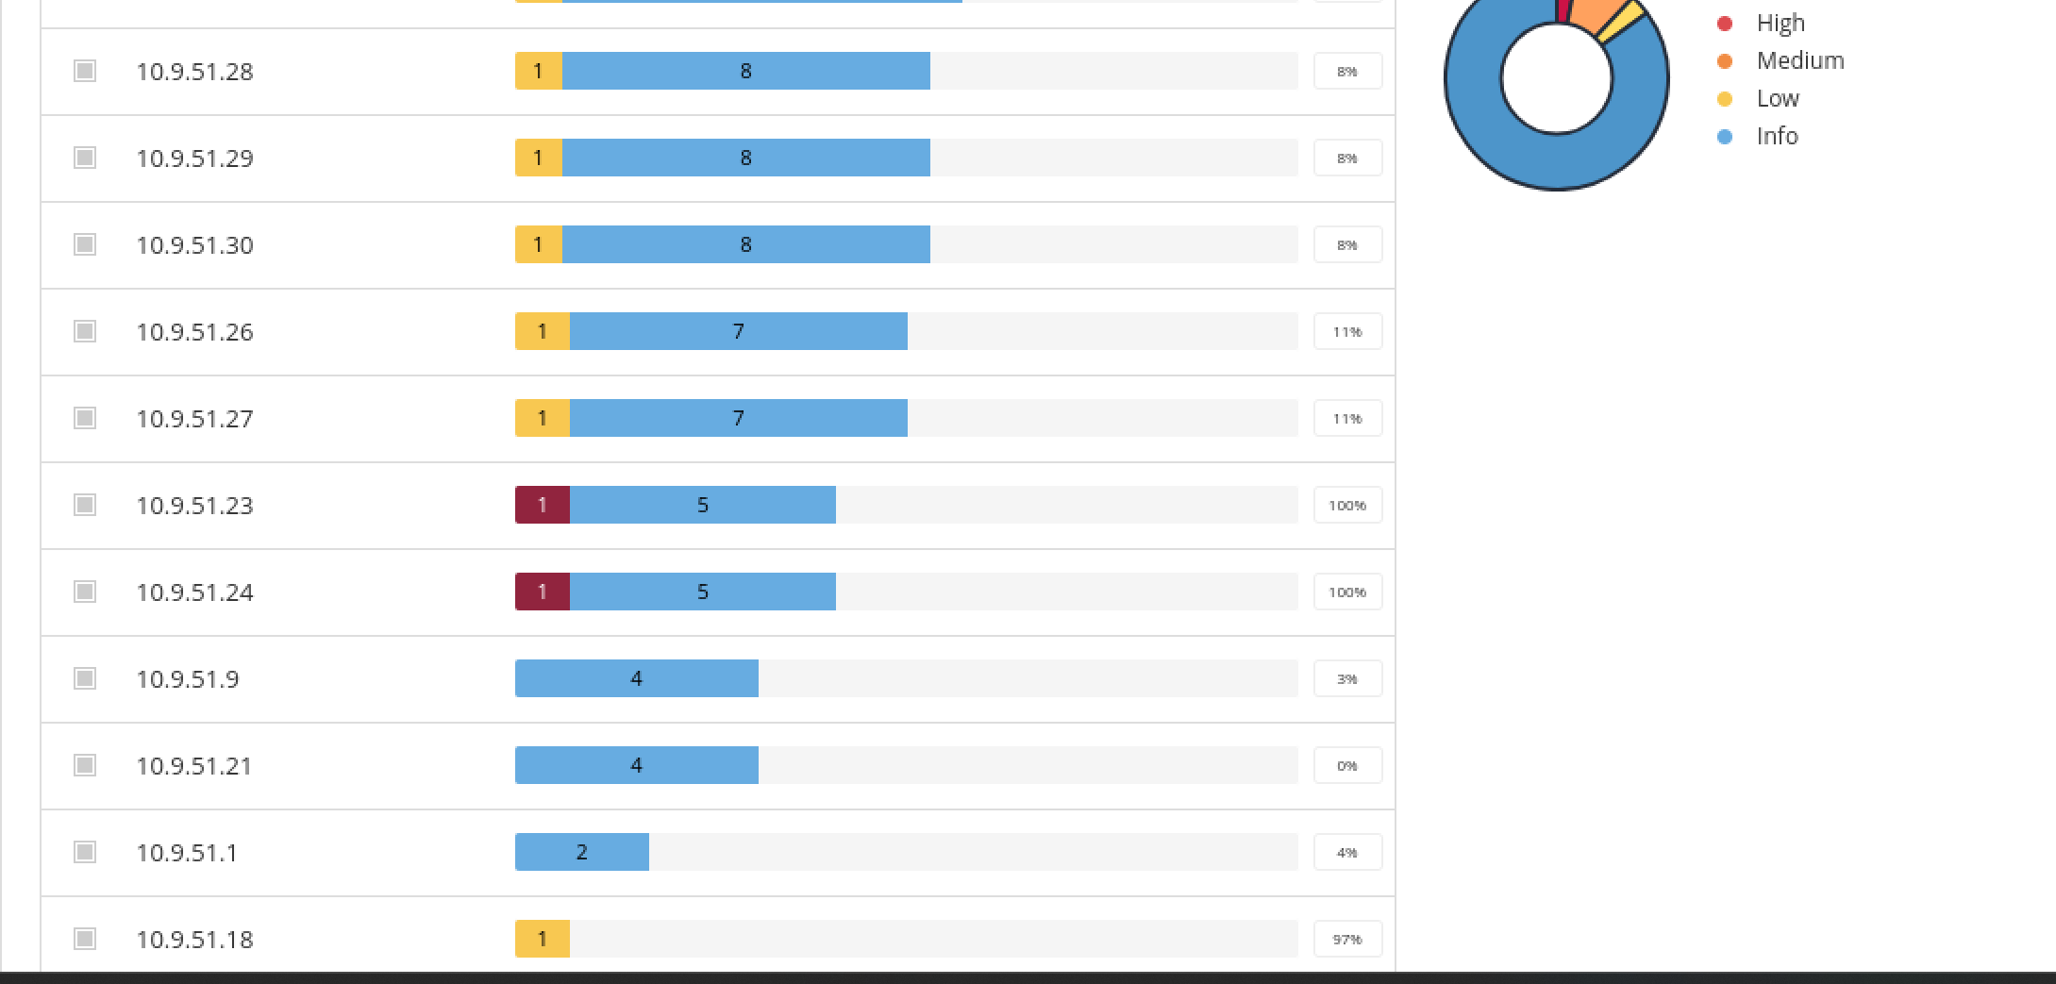

Scan result for IP address: 10.9.51.31
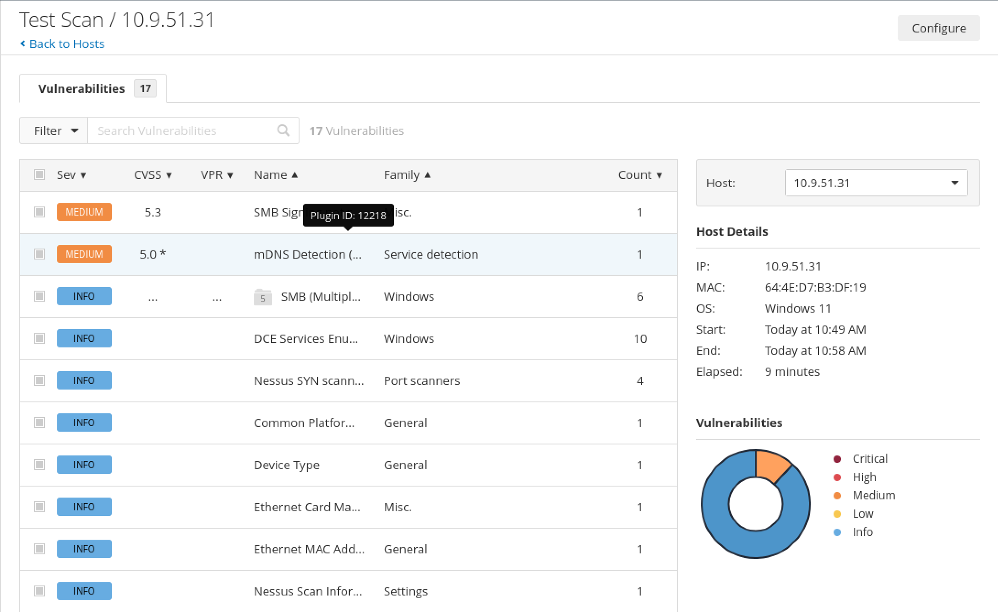

Test results for my host machine.
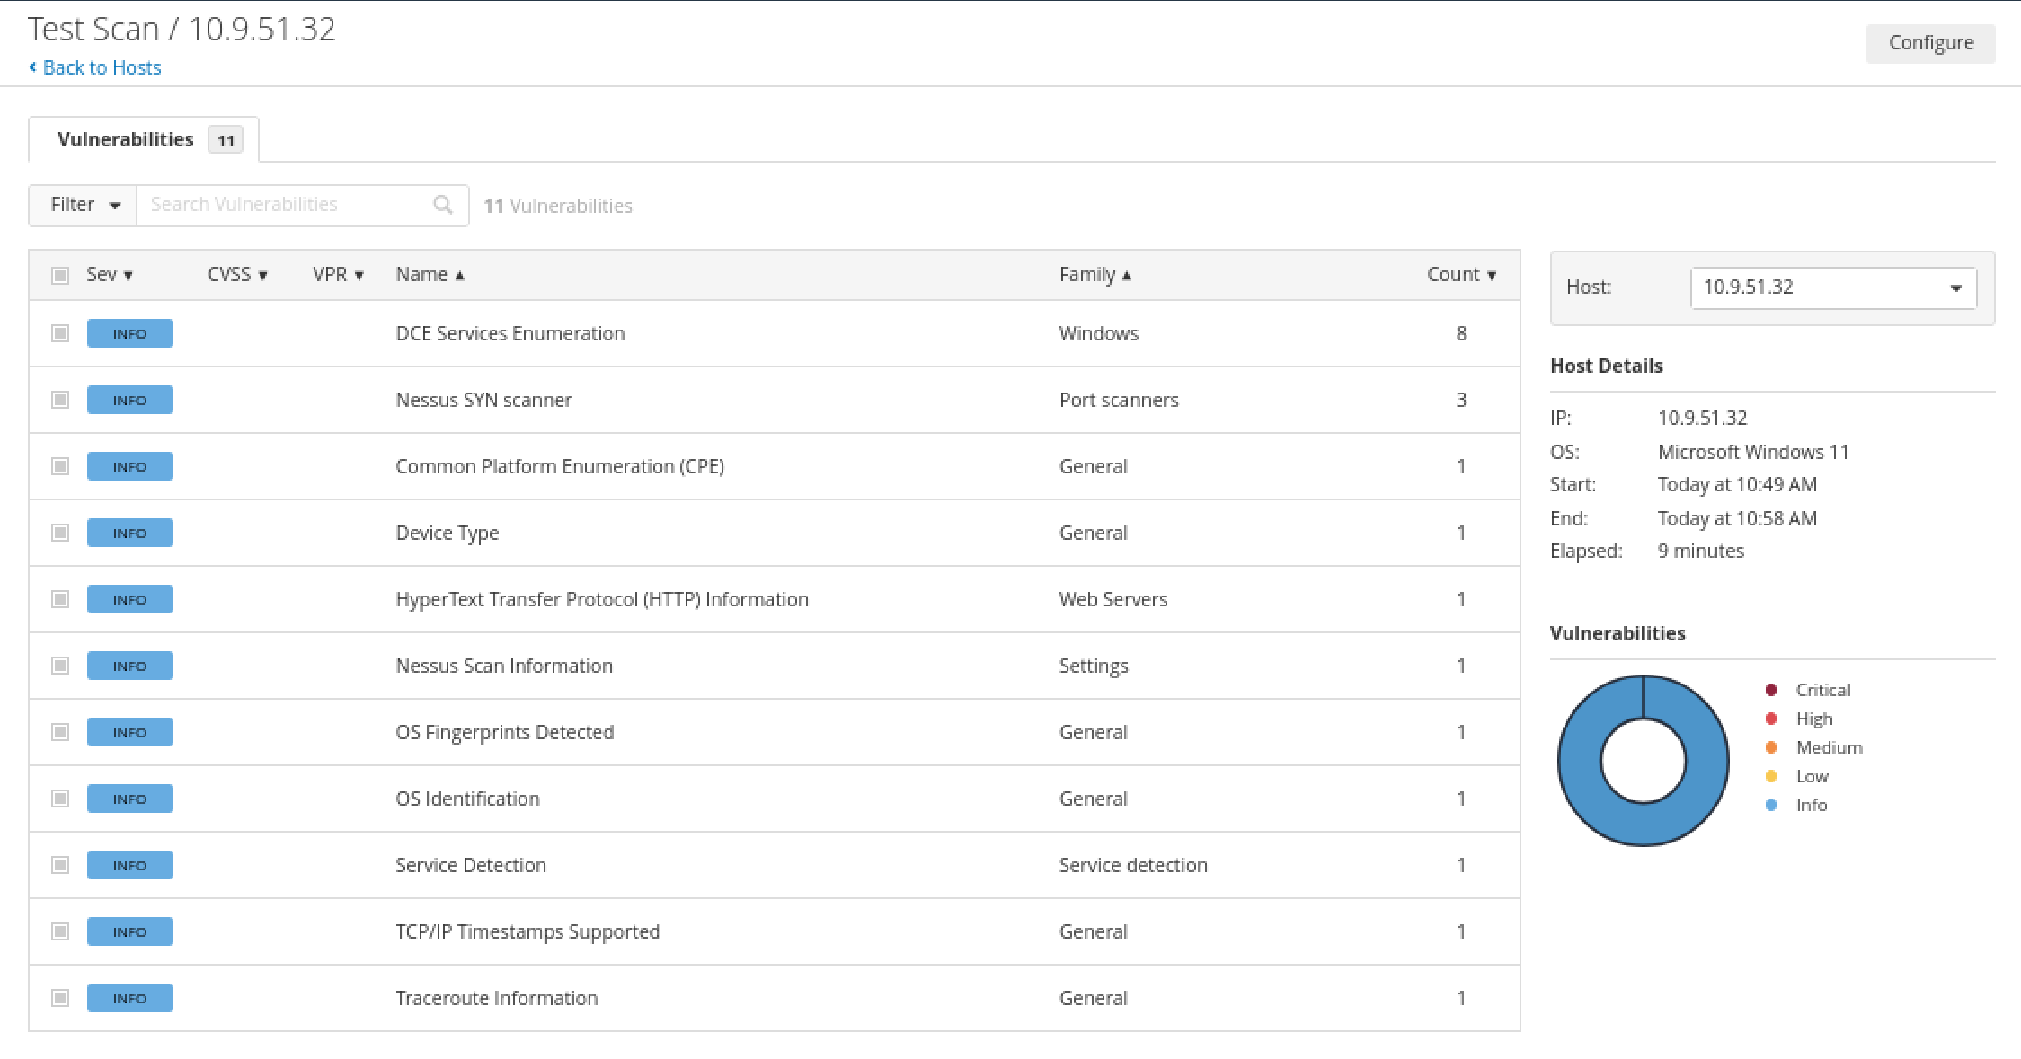

One of the critical vulnerabilities from the scan.
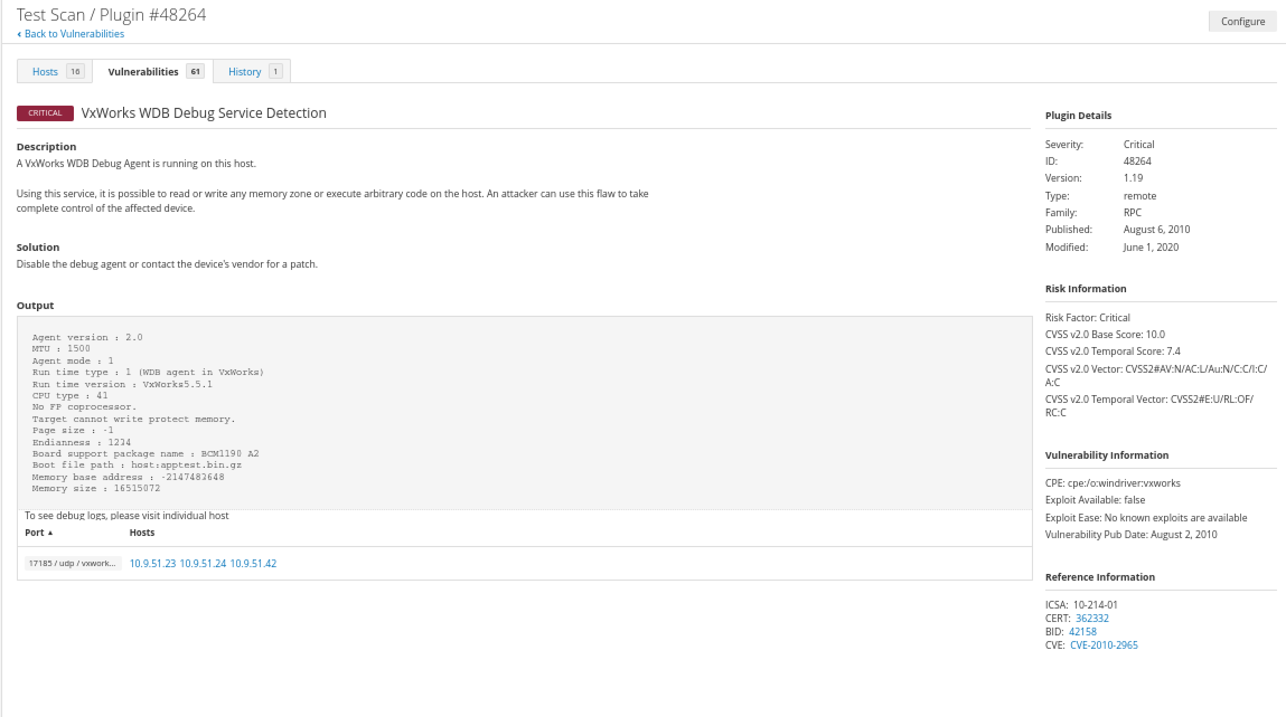

Scan complete: A total of 16 hosts and 61 vulnerabilities were identified.
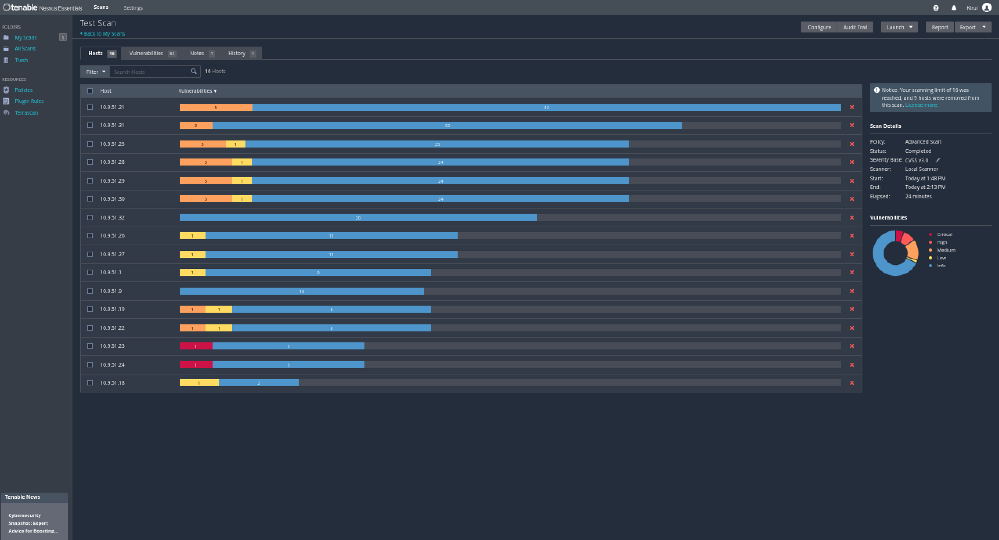

Scan results were limited due to licence issues.
